University of Notre Dame
Department of Computer Science and Engineering

CSE 60745
Graph Learning: Techn & Apps

Assignment Date:
Submission Date:
Student Name:

* This assignment contains 30 points. You are encouraged to finish independently. Any submitted work that is copied from any source or too similar to be an independent write-up will not be given credit. Please submit this homework (as a PDF or Word file including the cover page) to ND Canvas by 11:59pm on Monday, 10/12/2026.

In this assignment, you will practice the basic usage of PyTorch-Geometric and use the framework to address over-smoothing problem in deep GNNs. Please refer to PyG documentation for more technical details and use Google Colab for experiments. For each question, you will be asked to complete a MessagePassing() subclass as shown in the example below, where you need to specify the required components and aggregation strategy in __init__(), define propagated message in message(), and implement aggregation and node updation in forward(). You also need to complete reset_parameters() for parameter initialization.

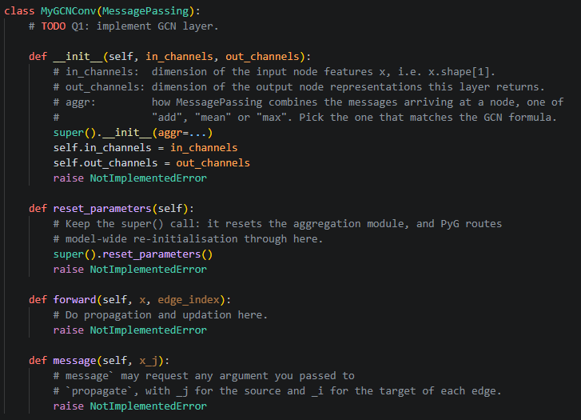

Q1: GCN Implementation (6 pts)
Complete MyGCNConv(). You can refer to `degree`, `add_self_loops` and `remove_self_loops` functions defined in PyG to assist adjacency matrix related computation.

Q2: GAT Implementation (6 pts)
Complete MyGATConv() in multi-head fashion. Use ` torch_geometric.utils.softmax` for softmax computation.

Q3: GIN Implementation (6 pts)
Complete MyGINConv(). Feel free to design your own MLP architecture.

Q4: R-GCN Implementation (6 pts)
Complete MyRGCNConv(). Please implement the basic version of R-GCN. Edge type labels are provided in `edge_type`.

Q5: Mitigate Over-Smoothing in Deep GNNs (6 pts)
Stacking too many GNN layers will make all node embeddings drift towards each other and cause over-smoothing problem. Please look into the literature on over-smoothing and implement MyDeepConv() to design a GNN model that stays useful with an 8-hop receptive field. Note that 8-hop receptive field is not equal to 8-layer GNN.

